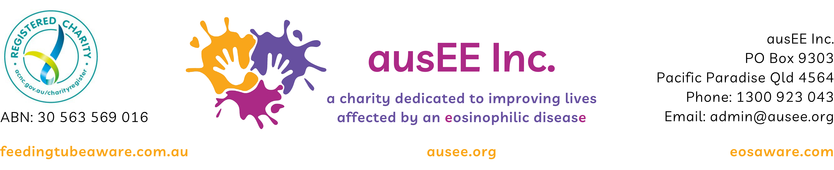
Application for Membership
ausEE Inc. is Australia’s peak national support and patient advocacy organisation representing Australians living with an eosinophilic disease, with an established focus on eosinophilic gastrointestinal diseases (EGIDs) including eosinophilic oesophagitis (EoE). We are a registered Australia wide charity whose mission is to improve the lives of those affected by eosinophilic diseases through providing support, evidence-based information, resources, advocacy and by campaigning to raise awareness and funds for research in Australia.
Upon my admission as a member of ausEE Inc. I agree to obey the rules and regulations laid down in the Constitution of ausEE Inc. and any rules and regulations made in accordance with that constitution.
(A copy of the Constitution is available from ausEE Inc.)

Personal Details: Mr / Mrs / Ms / Miss / Dr
Last Name |  | Given Names

Address
Postcode

Phone

Email

Membership carries no fee.

Note that ausEE Inc. has Public and Products Liability Insurance in an amount of $20,000,000 per occurrence.

Signature of Applicant  (electronic signature valid) |  | Date

Proposed by ________________________ Signed ___________________ Seconded by ________________________ Signed __________________

All applications are considered by the Management Committee at the first Committee Meeting following receipt of application, and all applicants are advised soon thereafter.

Please send this completed form by email to admin@ausee.org.

Committee use only:

Date Received |  | Considered by Committee on
Added to Members Register |  |  | Applicant Advised

